49er Sports - News Article Behavioral Diagrams

The following classes implement the news feed on the home page of our app; the Home page of the app should show a list of relevant sports, and each sport should have a list of recent news articles from the NCAA API.

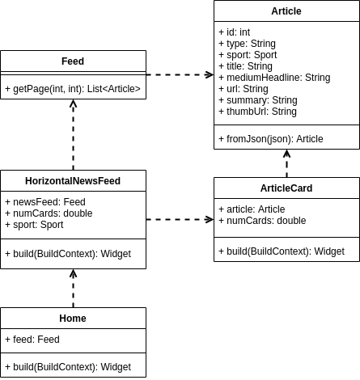

Home is the main widget for the homepage of the app. This will contain the list-of-lists of articles from NCAA.

HorizontalNewsFeed is a list of articles for a particular sport; one is created for each sport, and they are displayed in the Home widget.
Article is a DTO used to contain and transfer information about a given article.

ArticleCard is a widget that displays a short summary about a given article.
Feed is a wrapper that deals with paging through the NCAA API and converts the API responses to Article objects, which can then be used to construct the various widgets.
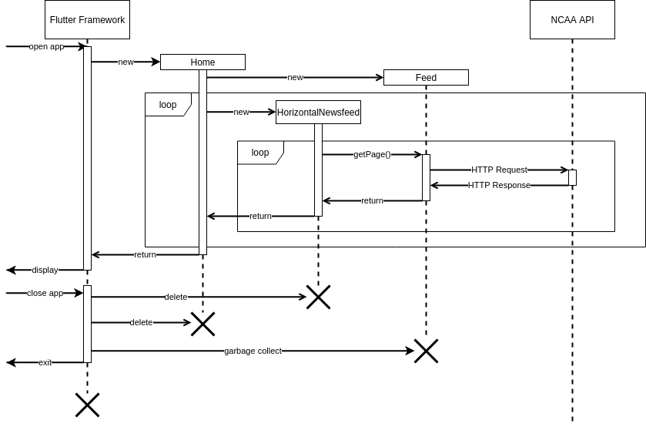
When the app is first opened, the Flutter framework is initialized. As part of that process, it instantiates a Home widget, which Instantiates a Feed widget.

When the Home widget is initialized, loop through all sports registered in the app and create a HorizontalNewsfeed for that sport, using the Feed wrapper already created.
When each HorizontalNewsfeed is created, use Feed to fetch several pages of content and convert the resulting Articles to ArticleCards. Return these to be displayed.

Eventually, when the home page is exited, flutter will remove all the widgets that have been created.
Feed is not a widget, but it will also be garbage collected once the Home widget is destroyed.

